MACH4METAL

metalworking machinery
Transito 21, 6909 DA Babberich, Netherlands
Tel. + 31 (0)316 – 247123
Fax. + 31 (0)316 - 247956
info@mach4metal.com
www.mach4metal.com
Bank No : 66.52.13.883
IBAN : NL33 INGB 0665 2138 83
BIC : INGBNL2A
VAT : NL 815393635B01

CNC Lathe DOOSAN PUMA 250 LMB

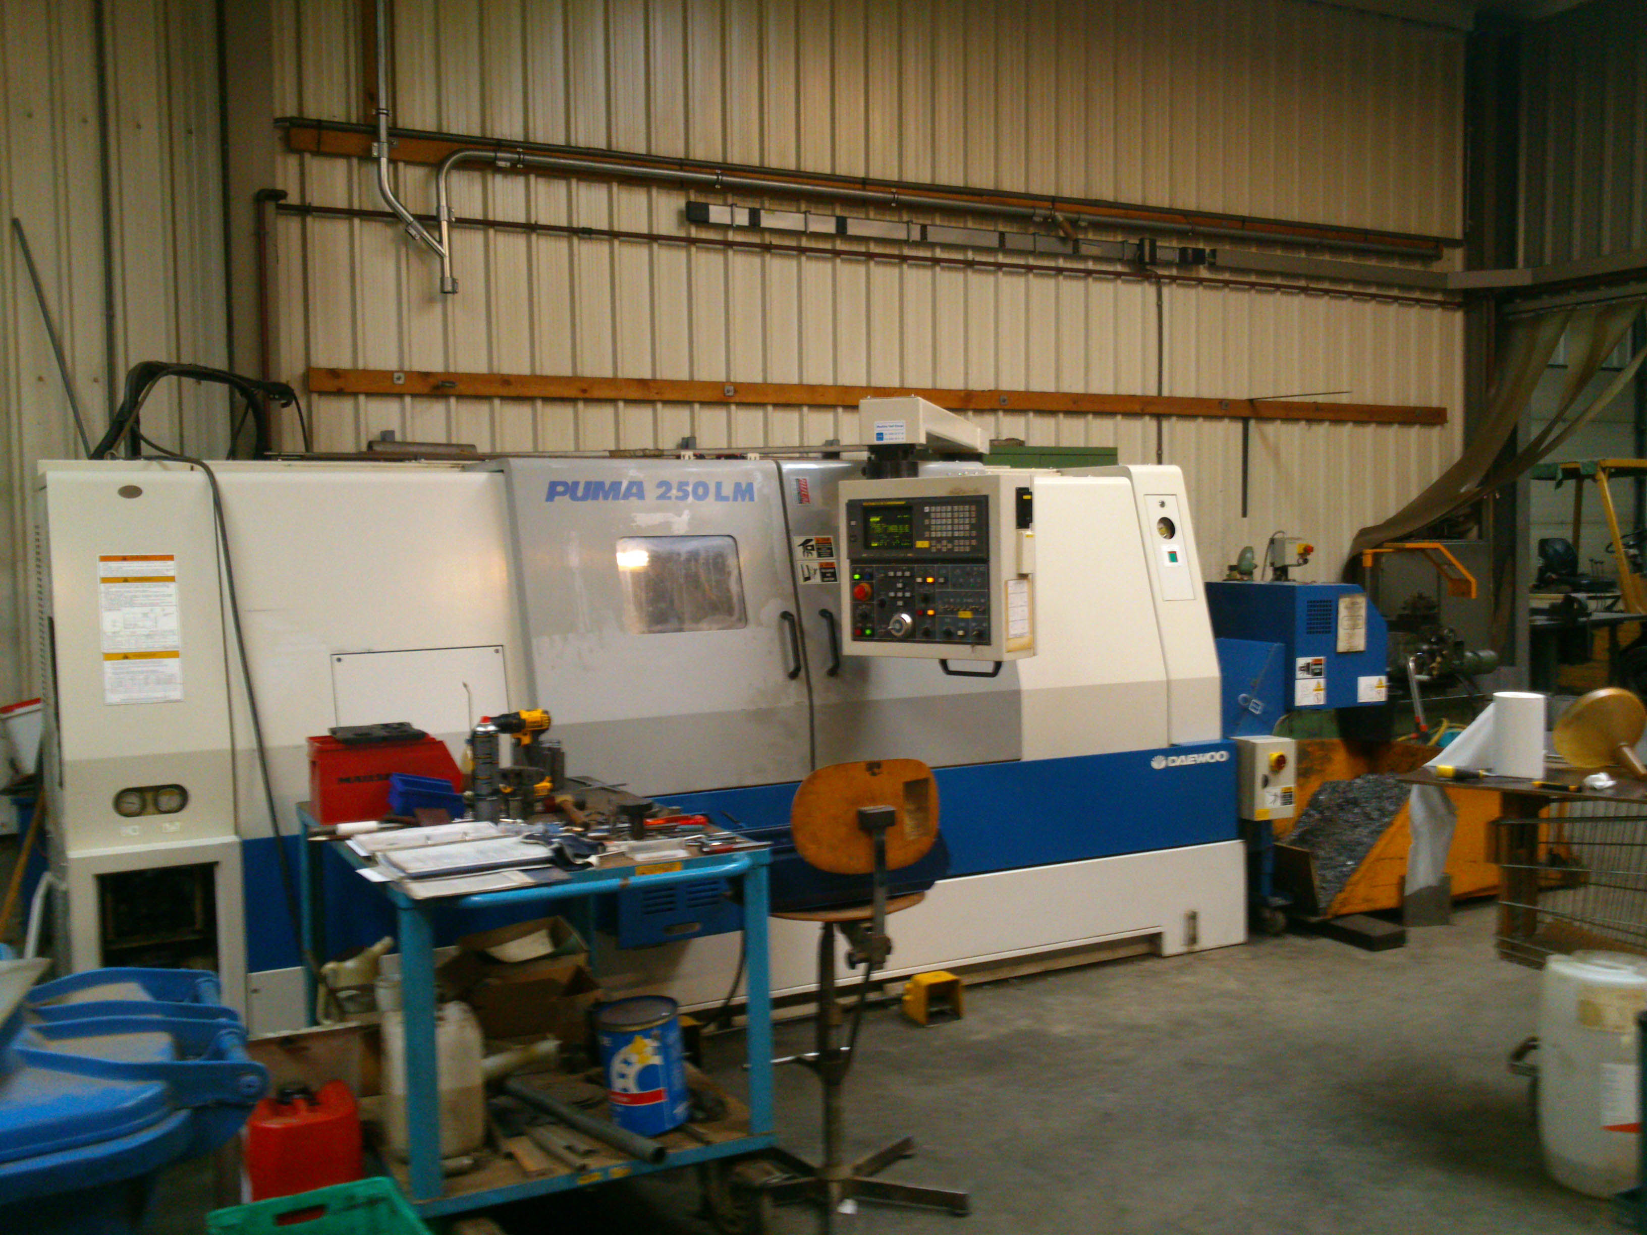
- Make : DOOSAN
- Typ : Puma 250 LMB
- Mach.No : 25LM0121
- Age : 1998

- Swing : 570
- Over slide : 370
- Center distance : 1.300
- Spindle hole : 77

- Speeds vario : 65 – 3.500 rpm.
- Stroke X axis : 282
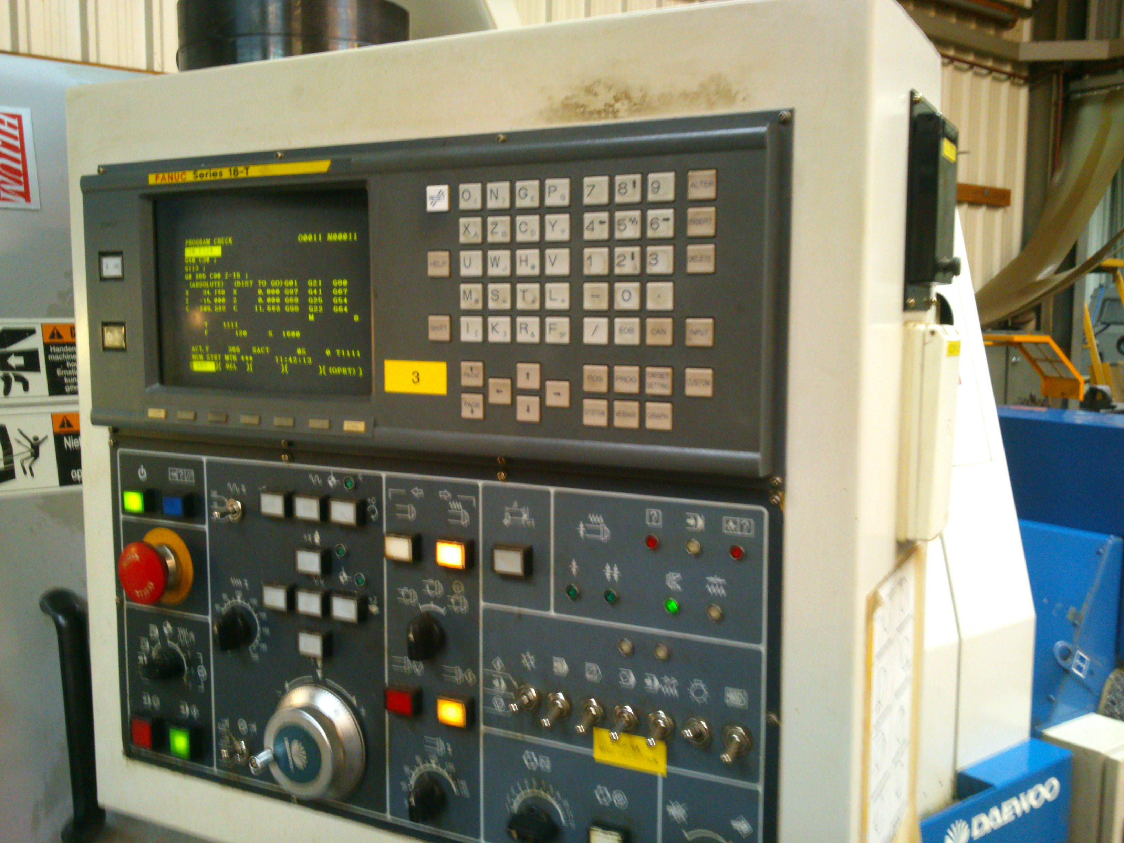
- Stroke Z axis : 1.330

- Rapid traverse X axis : 20.000 mm
- Rapid traverse Z axis : 24.000 mm

- Cutting feed X-Y : 0,001 – 500,000

- Turret 12 Positions VDi 40
- Live tooling 4000 Rpm
- Tail stock Quill Diam 100
- Bore taper Mk 5
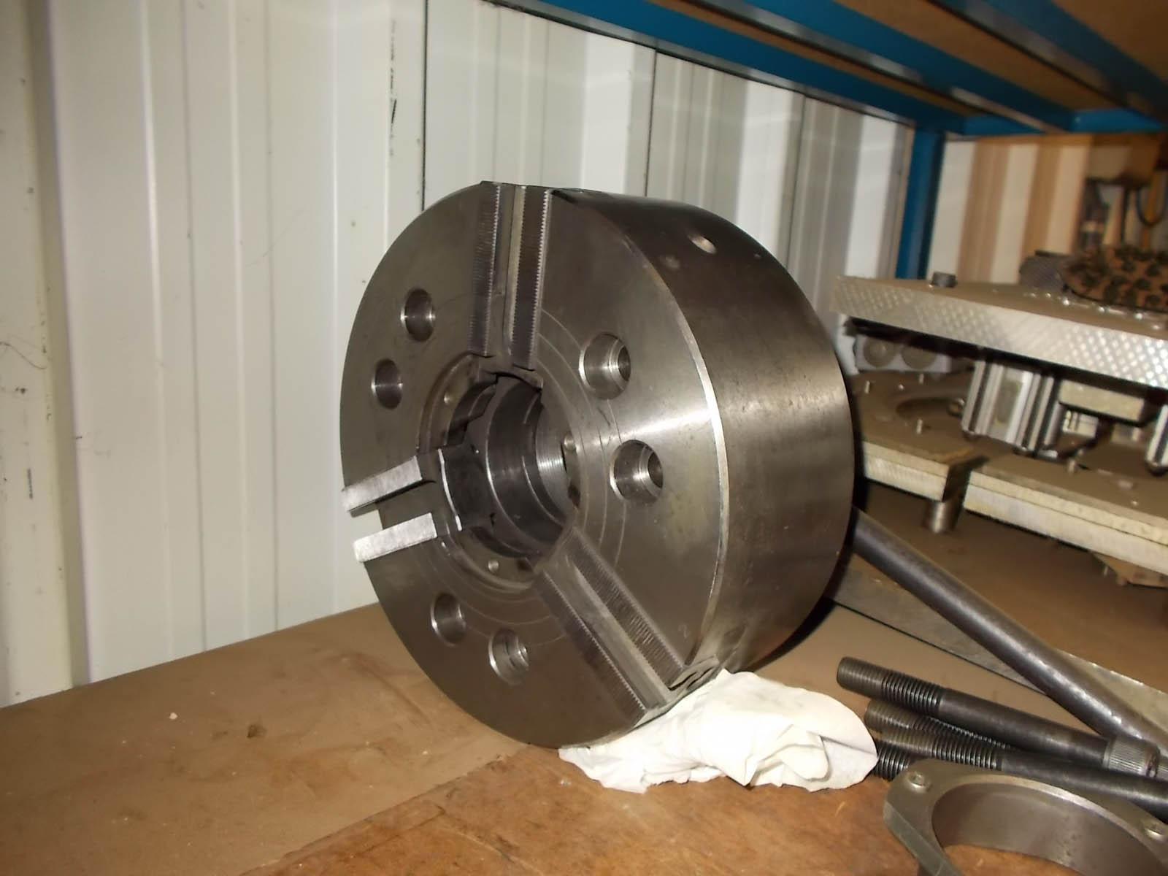

- Dimensions
- Length : 4.000 Ø
- Width : 1.980
- Height : 2.065
- Weight : 6.700

- CNC Fanuc 18 T
- Incl. chuck

Please Note: The above information has been obtained to the best of our ability and belief from, and from the manufacturers where possible. It is given in good faith, but its accuracy can not be guaranteed. Accordingly, it will not form a representation or constitute contractual terms. We advise you to check any vital details

